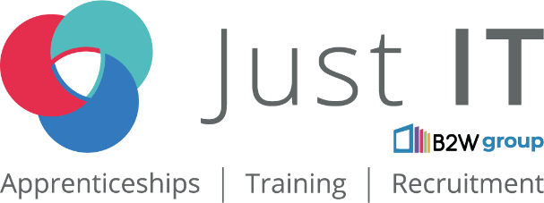

Data Technician

Name:
Course Date:
Table of contents
Day 1: Task 1 3
Day 1: Task 2 4
Day 1: Task 3 5
Day 1: Task 4 6
Day 2: Task 1 7
Day 2: Task 2 8
Day 2: Task 3 12
Day 3: Task 1 13
Day 3: Task 2: Skillable 14
Day 3: Task 3: Skillable 16
Day 4: Task 1: MS Fabric using Just IT 17
Day 4: Task 2: Skillable 17
Day 4: Task 3 (Optional) 18
1. Scenario Background 18
2. Data Laws and Regulations 18
3. Azure Service Recommendations 18
4. Data Types and Data Modelling 18
5. Data Storage Formats and Structures in Azure 19
6. Additional Considerations 19
Submission Guidelines: 19
Course Notes 22
Additional Information 23

Day 1: Task 1

Please research and complete the below questions relating to key concepts of cloud.

Be prepared to discuss the below in the group following this task.

What can cloud computing do for us in the real-world? | Enables organizations to access computing resources—such as storage, servers, and applications—over the internet, eliminating the need for heavy on-premises infrastructure. Its advantages span flexibility, efficiency, and strategic value.
How can it benefit a business? | cost savings, scalability, enhanced security, and improved collaboration
What’s the alternative to cloud computing? | On-premise computing
What cloud providers can we use, what are their features and functions? | AWS -  Scalable and flexible, offers over 200 fully-featured services  MS Azure – hybrid cloud capabilities and compliance coverage  GCP – excels in big data and analytics; has machine learning and data analytics capabilities.  IBM Cloud – a range of services from IAAS to PAAS, hybrid cloud support  Oracle Cloud – Cloud apps and services for ERP; known for database services and enterprise applications

Day 1: Task 2

Pricing Calculator: In this exercise, you use the Pricing calculator to estimate the cost of running a basic web application on Azure.
Exercise - Estimate workload costs by using the Pricing calculator - Training | Microsoft Learn

Cost of a basic web application | Estimated Monthly Cost 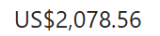

Day 1: Task 3

Please research the below cloud offerings, explain what they are and examples of use cases.

Cloud Offerings | Explain what it is | When / how might you use this service in the real-world?
IaaS (Infrastructure as a service) | Providing fundamental IT resources like servers, storage, and networking on demand, allowing businesses to rent virtual infrastructure instead of buying physical hardware. The user controls the operating systems, applications and data. | Might be used to host websites, or for big data analytics and processing
PaaS (Platform as a service) | Allows developers to have a complete environment -  hardware, software, tools, databases, operating systems—to build, run, and manage applications without the burden of maintaining the underlying infrastructure. | Building web and mobile apps, creating AI and ML models; Developing applications with integrated communication; Managing big data analytics
SaaS (Software as a service) | Applications are delivered over the internet on a subscription basis.  The vendor hosts the software on their servers, handles maintenance, security, and updates. | Using in a workplace to access services from various locations without the need to develop own software applications. E.g. Google Workspace, MS Office 365, Salesforce

Day 1: Task 4

Please research the below terms and explain what they are, when they would be appropriate and a real-world example of where it could be implemented (i.e. what type of organisation).

Public Cloud | Third-party cloud service provided by organisations such as AWS, GCP
Private Cloud | The organization purchases server hardware, maintains it in a central data center, and delivers the resources to the different departments over a network.
Hybrid Cloud | Hybrid cloud offerings let you seamlessly switch workloads between different environments. For instance, when organizations run out of computing resources in their internal data center, they burst the extra workload to external third-party cloud services.
Community Cloud | A community cloud is a type of cloud computing environment that is shared by multiple organizations with common goals, security requirements, or regulatory needs.  Community clouds are particularly useful for organizations in regulated sectors, such as healthcare, government, and education, as they allow for customized security protocols and compliance frameworks tailored to the community's needs. They balance the security and privacy of private clouds with the cost savings of shared infrastructure

Day 2: Task 1
You are a Cloud Consultant hired by a client. You will identify the most suitable cloud service model for a client requiring control over infrastructure, estimate potential cloud costs, and explain the benefits of cloud adoption.
🏭 Client – "DataCore Enterprises"
- A large enterprise wants to move its internal database servers to the cloud.
- They already have IT staff.
- They want full control over operating systems and storage configuration.
Questions for you:
- Which service model suits them? (IaaS, PaaS, Saas)
- IAAS
- How can they estimate the cost of using cloud services?
- Using a Pricing Calculator
- What are the possible benefits of using cloud services?
Scalability; own the control over storage, OS, applications; cost-efficient – no hardware spend; high-performance data centres; robust backup and recovery
- Bonus: What might be potential risks?
- Misconfigurations, weak authentication may be an easy target for attackers. There’s a risk of data leaks, data loss, less control over the equipment than on-prem, and compliance issues

Day 2: Task 2

Describe, with examples, the three major areas that the Computer Misuse Act deals with.

Area | Description | Example
Unauthorized Access to Computer Material | This offense occurs when a person gains access to a computer system without permission. It is punishable by up to two years in prison. | Use someone else’s password to gain access into their phone and download photos.
Unauthorized Access with Intent to Commit Further Offenses | This provision addresses cases where unauthorized access is used to facilitate other crimes, such as fraud or theft. | Obtaining bank details without permission with the intent to transfer money from someone’s account.
Making, Supplying, or Obtaining Articles for Use in Offenses | This provision targets the distribution of tools or software intended for committing computer crimes. | You downloaded a programme which was able to take remote control of a friend’s computer without their knowledge. You didn’t get a chance to use it before you were caught. This offence covers the possession of ‘malware’ but also legitimate software for which you had the intent of using it to commit an offence.

The computer misuse act 1990 is an act where an individual can be criminalised because of computer related offense. Describe three extra powers that the Police and Justice Act 2006 (Computer Misuse) has added.

Description
Increased Penalties: The Act doubles the maximum prison sentence for hacking into computer systems from five years to ten years. This change reflects the seriousness of computer-related crimes in the digital age.

Unauthorized Access and Modification: The amendments clarify that unauthorized access to computer material and unauthorized modification of computer material are offenses. A person is guilty if they perform an unauthorized act with the intent to impair the operation of any computer or prevent access to any program or data.
Creation of Hacking Tools: The Act introduces a new offense for creating and distributing tools intended for hacking, which addresses the growing concern over the availability of such tools in the market. However, it also raises concerns about the implications for security professionals who may need similar tools for legitimate purposes.

Look at the below website to answer the questions:
https://www.gov.uk/personal-data-my-employer-can-keep-about-me

Write down three items of data which a company can store about an employee.
National Insurance Number
Date of Birth
Address

Give three more examples of data that an employer can only store if they first get the employee’s permission.
Race and Ethnicity
Religion
Health and Medical Conditions

Conduct further research to answer the below questions.

Question | Answer
Provide one example of: Copyright infringement | Apple vs. Samsung (2011)– Samsung was sued for patent infringement and had to pay damages to Apple.
Provide one example of: Plagiarism | Copying and pasting from web pages and online sources.
What are two consequences of copyright infringement and software piracy? | Reputational damage; Legal costs
Give three possible consequences for individuals when using pirated software | Civil fines, criminal charges, legal liability

Listed below are some laws which we have covered today:

1. Computer Misuse Act 1990
2. Police and Justice Act 2006 (Computer Misuse)
3. Copyright, Designs and Patents Act 1988
4. Copyright (Computer Programs) Regulations 1992
5. The Health and Safety (Display Screen Equipment) Regulations 1992
6. Data Protection Act 2018
7. Consumer Rights Act 2015

- Insert a number in the first column of each row to match each of the statements with one of the above Acts.

- One of statements is incorrect and not illegal. For this statement, write ‘Not illegal’.

Act number | Clause
3 | With some exceptions, it is illegal to use unlicensed software
7 | Any product, digital or otherwise, must be fit for the purpose it is supplied for
1 | Unauthorised modification of computer material is illegal
Not illegal if it is authorised | It is illegal to create or use a hacking tool for penetration testing
6 | Personal data may only be used for specified, explicit purposes
5 | Employers must provide their computer users with adequate health and safety training for any workstation they work at
1 | It is illegal to distribute hacking tools for criminal purposes
6 | It is illegal to distribute an illicit recording
6 | Personal data may not be kept longer than necessary
1 | Gaining unauthorised access to a computer system is illegal
5 | Employers must ensure that employees take regular and adequate breaks from looking at their screens
1 | It is illegal to prevent or hinder access (e.g. by a denial-of-service attack) to any program or data held in any computer
6 | Personal data must be accurate and where necessary kept up to date

Day 2: Task 3

Please complete this activity to the best of your ability. This is an introduction to Azure Cloud Computing. You can skip Exercises as we will complete day later.
Introduction to Cloud Infrastructure: Describe Azure Architecture and Services - Training | Microsoft Learn

Day 3: Task 1

Please complete the below lab (1) ‘Explore relational data in Azure’ and paste evidence of the completed lab in the box provided.

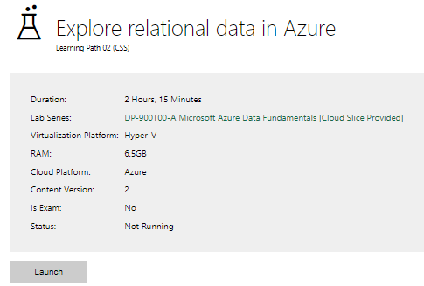

Completed lab | 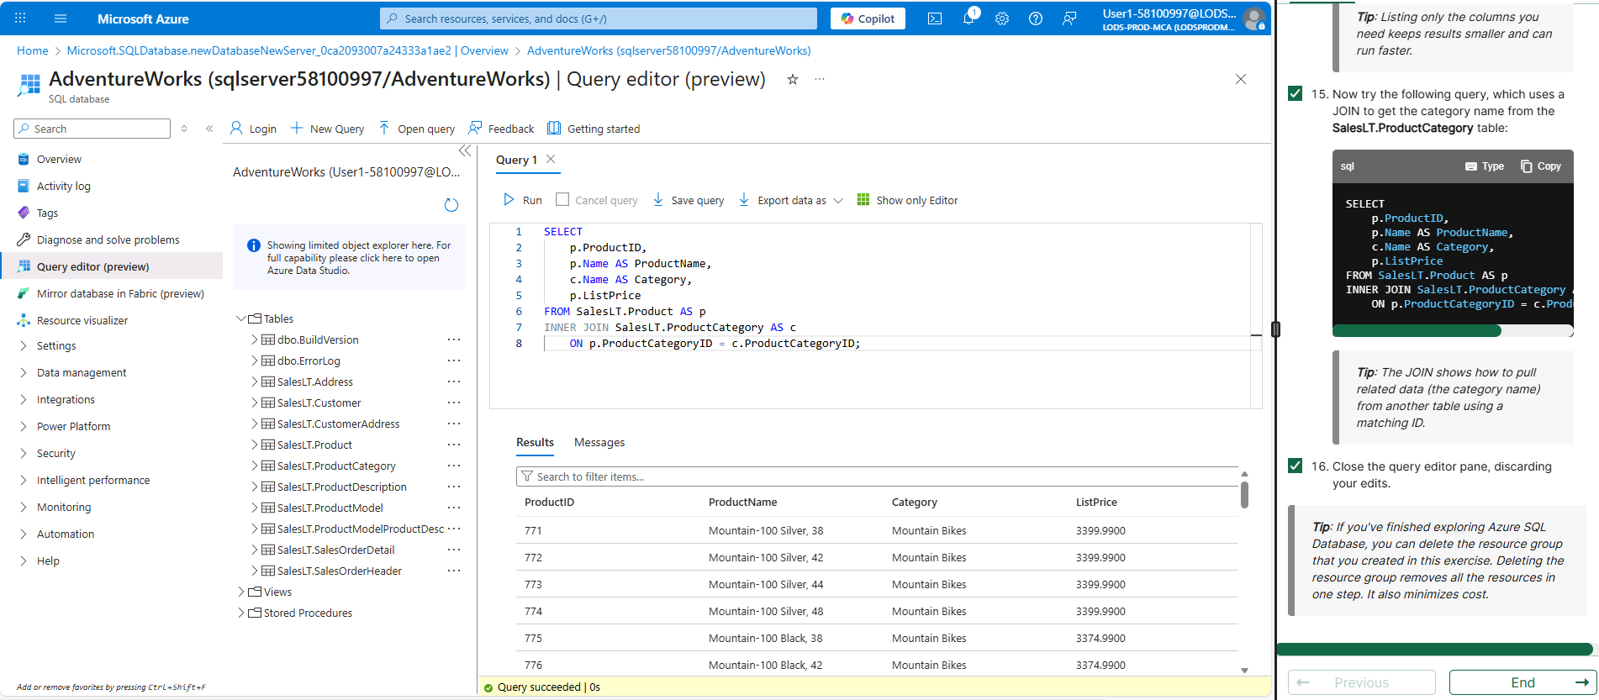

Day 3: Task 2: Skillable
Complete below exercises in lab environment using AdventureWorks DB.
You can view Schema Design here.
-- 1. Customers with last names starting with 'A'
-- Scenario: The marketing department is preparing a campaign targeting customers whose last names begin with the letter 'A'. They need a list of these customers to personalize outreach messages.
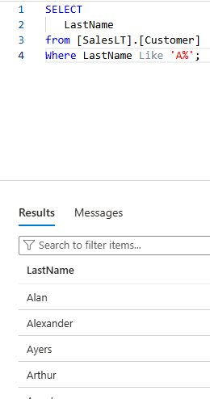

-- 2. Customers with first name starting with 'A' and last name ending with 'a'
-- Scenario: The CRM team is analyzing customer name patterns for personalization strategies. They're particularly interested in users with a first name starting with 'A' and a last name ending in 'a'.
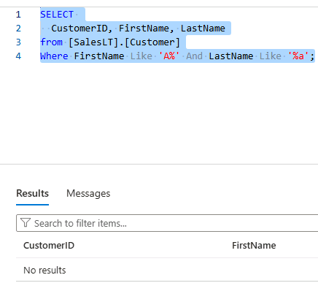

-- 3. Count of customers with first name starting with 'A' and last name including 'o'
-- Scenario: A data analyst is generating statistics for a name segmentation report and needs to count how many customers meet both criteria: first name starts with 'A' and last name contains the letter 'o'.

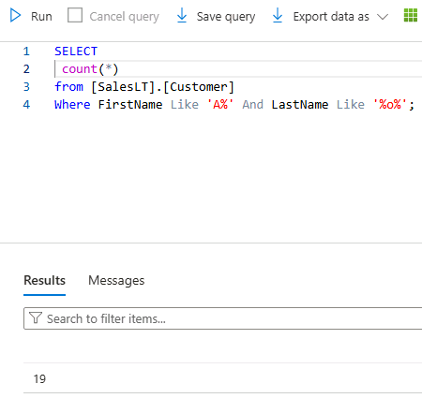

-- 4. Top 3 black products of size 'S' ordered by list price
-- Scenario: The merchandising team is curating a list of 'Black' colored products in size 'S' for a limited-time promotion. They want to showcase the top 3 most affordable options first.

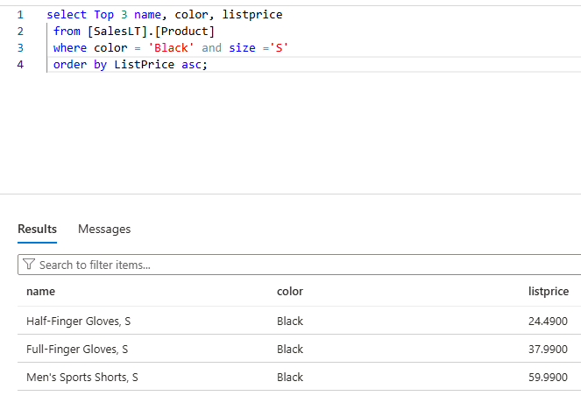

-- 5. Average standard cost of products
-- Scenario: The finance team is calculating the average standard cost across all products to assess baseline production expenses.
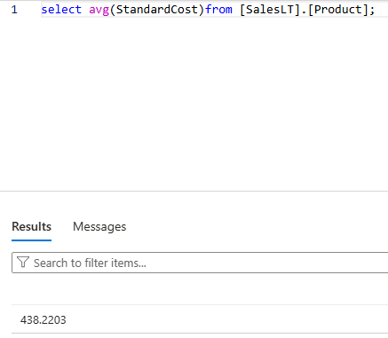

-- 6. Difference between average standard cost and average list price
-- Scenario: The pricing strategy team is examining the average markup between the standard cost and the list price to evaluate profitability trends.

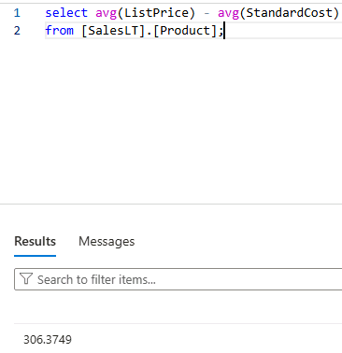

-- 7. Product with highest profit margin
-- Scenario: Management wants to identify the most profitable product by finding the item with the highest difference between list price and standard cost.

-- 8. Number of products per category
-- Scenario: Inventory control needs a summary of how many products exist in each product category to manage stock levels effectively.

SELECT c.Name, COUNT(p.Name) AS Total
FROM SalesLT.Product AS p
INNER JOIN SalesLT.ProductCategory AS c
ON p.ProductCategoryID = c.ProductCategoryID
GROUP BY c.Name
ORDER BY Total DESC;

-- 9. Average list price by category
-- Scenario: The product pricing team is reviewing average list prices by category to adjust pricing strategies and identify outliers.

SELECT ProductCategoryID, AVG(ListPrice) AS AveragePrice
FROM SalesLT.Product
GROUP BY ProductCategoryID;

-- 10. Orders with customer information
-- Scenario: The operations team needs a comprehensive report of customer orders, including order details and basic customer info, to review sales performance.

select [SalesLT].[Customer].customerid, [SalesLT].[Customer].firstname, [SalesLT].[Customer].lastname, [SalesLT].[SalesOrderDetail].unitprice
from [SalesLT].[Customer]
join [SalesLT].[SalesOrderHeader]
on [SalesLT].[Customer].customerid = [SalesLT].[SalesOrderHeader].customerid
join [SalesLT].[SalesOrderDetail]
on [SalesLT].[SalesOrderHeader].salesorderid = [SalesLT].[SalesOrderDetail].salesorderid;

-- 11. Products priced above average list price
-- Scenario: The sales team wants to identify premium products that are priced above the average list price for highlighting in high-end marketing campaigns.

SELECT ProductID, Name, ListPrice
FROM SalesLT.Product
WHERE ListPrice > (SELECT AVG(ListPrice) FROM SalesLT.Product);

-- 12. Total quantity sold per product
-- Scenario: The business intelligence team is evaluating product performance by analyzing the total quantity sold for each product across all orders.

SELECT p.ProductID, p.Name, SUM(sod.OrderQty) AS TotalQuantitySold
FROM SalesLT.SalesOrderDetail sod
INNER JOIN SalesLT.Product p ON sod.ProductID = p.ProductID
GROUP BY p.ProductID, p.Name;

-- 13. Total sales per customer
-- Scenario: The customer success team wants to calculate the total value of orders placed by each customer to identify high-value clients for loyalty programs.

SELECT c.CustomerID, c.FirstName, c.LastName, SUM(soh.TotalDue) AS TotalSales
FROM SalesLT.SalesOrderHeader soh
INNER JOIN SalesLT.Customer c ON soh.CustomerID = c.CustomerID
GROUP BY c.CustomerID, c.FirstName, c.LastName;

Day 3: Task 3: Skillable

Please complete the below lab (4) ‘Explore non-relational data in Azure’ and paste evidence of the completed lab in the box provided.

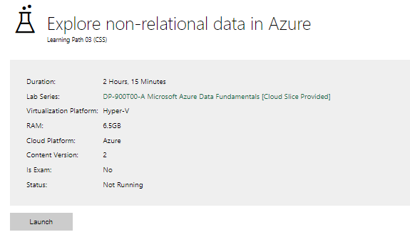

Completed lab | 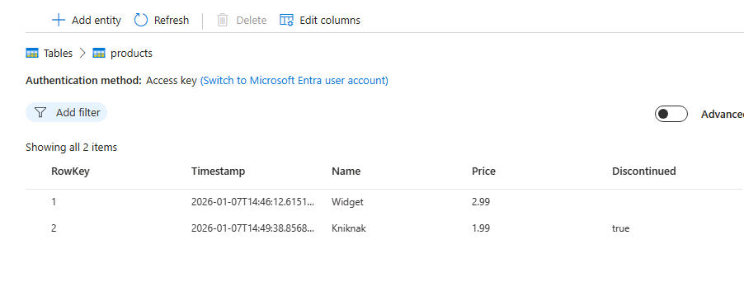  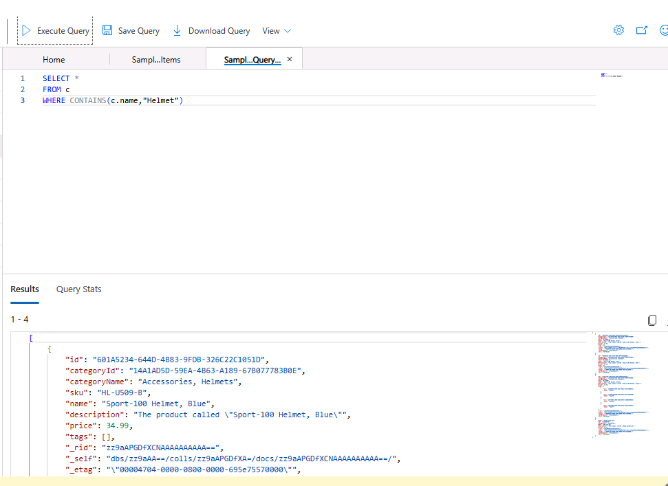

Day 4: Task 1: MS Fabric using Just IT
Please follow the link below to complete the lab using your Just IT account in MS Fabric.
There are 3 modules to complete.

Data Factory end-to-end tutorial introduction and architecture - Microsoft Fabric | Microsoft Learn

Lab 3
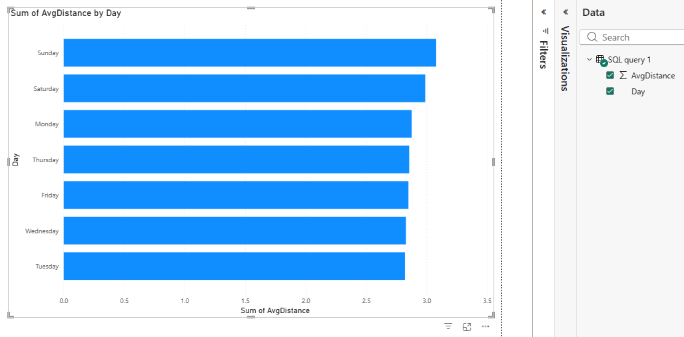

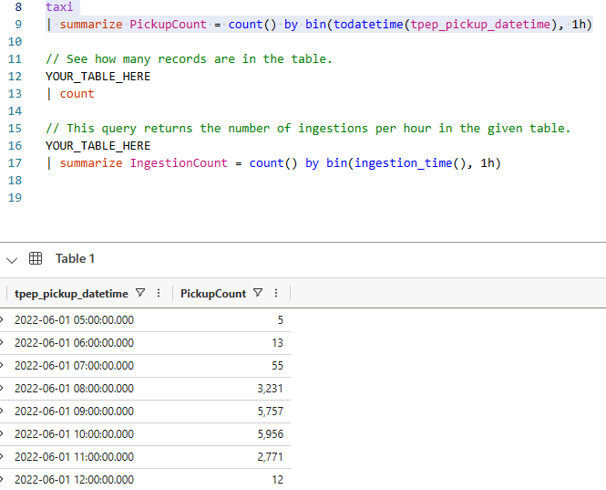

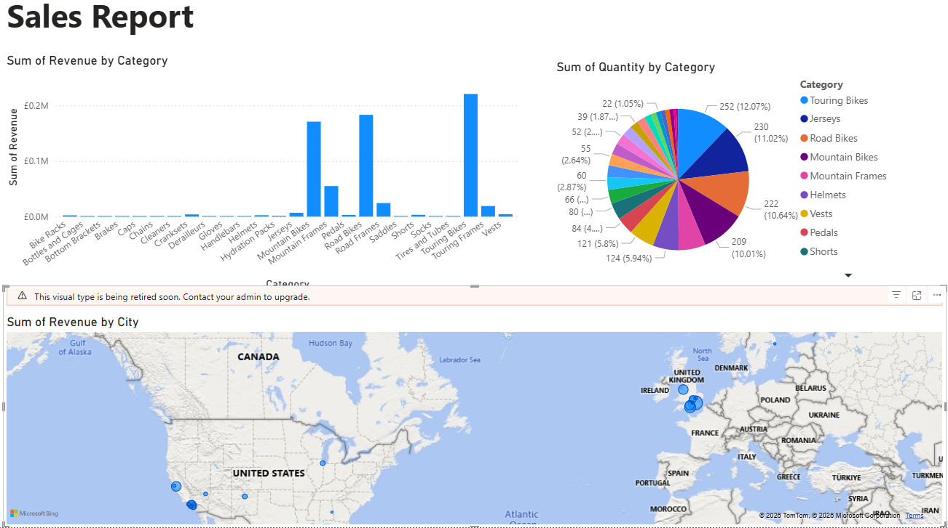

Day 4: Task 2: Skillable

In your teams, complete the Azure DP-900 practice exam and paste your result below – this is open book and please research and discuss your answers as a team.

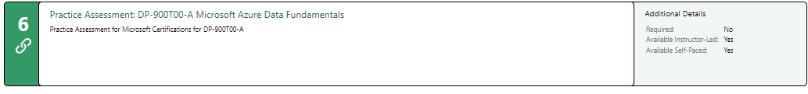
Result | Completed  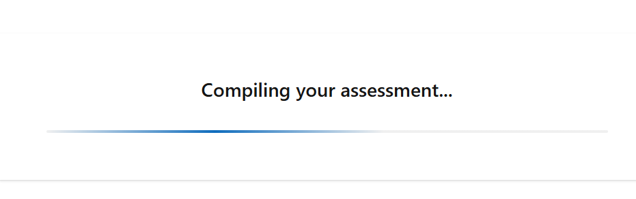

Day 4: Task 3 (Optional)

1. Scenario Background
"Paws & Whiskers" is a growing pet shop that aims to improve its business by analysing sales, customer information, and inventory data. Currently, the data is collected manually or stored in spreadsheets. Management is interested in transitioning to Microsoft Azure to streamline data storage, analysis, and reporting, enabling them to make data-driven decisions.

2. Data Laws and Regulations
Identify and explain the data laws and regulations relevant to handling customer data within the proposal. Ensure you cover the following points:
- GDPR Compliance: Highlight the importance of adhering to the General Data Protection Regulation (GDPR), particularly as it relates to storing and processing customer information.
- Data Protection Act (DPA) 2018: Outline how the DPA 2018 may affect the way "Paws & Whiskers" collects and stores data, ensuring compliance with UK laws on data privacy.
- Other Industry Standards: Research any additional data protection standards or regulations that may apply to pet shop data, particularly if they involve sensitive or payment information.

3. Azure Service Recommendations
Recommend Microsoft Azure services that would suit the company’s data analysis needs and explain why these services are suitable. Your recommendations should include:
- Data Storage: Identify suitable storage options, such as Azure Blob Storage or Azure SQL Database, and discuss the benefits of each for storing large datasets, including inventory, sales transactions, and customer details.
- Data Analysis Tools: Recommend tools such as Azure Machine Learning for customer behaviour analysis or Azure Synapse Analytics for analysing sales trends.
- Data Integration and Automation: Explain how services like Azure Data Factory could automate data collection and integration processes, improving efficiency.

4. Data Types and Data Modelling
Define the types of data "Paws & Whiskers" will need to work with and describe your approach to data modelling:
- Data Categories: Identify key data types, such as customer demographics, transaction history, pet inventory, and product categories.
- Data Modelling Approach: Outline how you would structure this data using a relational model or a data warehouse approach, considering factors like tables, entities, relationships, and primary keys.

5. Data Storage Formats and Structures in Azure
Discuss how you would store data within Azure and the formats you would recommend:
- Data Formats: Specify recommended formats (e.g., CSV for raw data imports, JSON for structured data, Parquet for analytics) and explain why these formats are suitable for specific data types.
- Data Security and Encryption: Include recommendations for securing data using Azure’s built-in encryption features and access controls to ensure compliance with data privacy regulations.

6. Additional Considerations
Provide any other considerations that might enhance data handling and efficiency in Azure, such as:
- Backup and Disaster Recovery: Outline a backup plan using Azure Backup or Azure Site Recovery to safeguard against data loss.
- Data Visualisation: Discuss potential use of Power BI within Azure for creating dashboards that provide management with real-time insights into sales and customer trends.
- Future Scalability: Comment on how Azure services can scale as the business grows, accommodating larger datasets and more complex analyses.

Submission Guidelines:
- Structure: Ensure your report is well-organised, with sections for each task (e.g., Data Laws, Azure Services, Data Types, etc.).
- Formatting: Include headings, bullet points where appropriate, and any visuals or diagrams that support your explanations.
- References: Cite any resources or regulations referenced in the report.
- Length: Aim for 1500-2000 words.

Course Notes

It is recommended to take notes from the course, use the space below to do so, or use the revision guide shared with the class:

Additional Information

We have included a range of additional links to further resources and information that you may find useful, these can be found within your revision guide.

END OF WORKBOOK

Please check through your work thoroughly before submitting and update the table of contents if required.

Please send your completed work booklet to your trainer.

